CRANIOSACRAL THERAPY/Myofascial release WORKSHOP
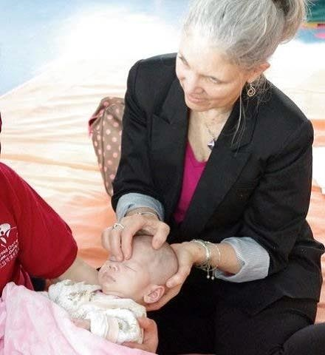  POINTS OF STILLNESS  2705 ENLOE STREET  HUDSON, WI 54016  715.690.2600  www.pointsofstillness.com |  | Instructor:  Nancy Lawton-Shirley, OTR/L  This hands-on workshop teaches basic skills in craniosacral therapy for integration into clinical practice. Learn how these techniques work for range of motion, sensory processing and other therapeutic outcomes for children and adults.  This workshop is recommended for OT, PT, SLP & Massage Therapists.  Registration Required  Questions?? Email info@pointsofstillness.com
APRIL 18 & 19, 2020
8:30 AM – 5:00 PM

Cost: $350

CRANIOSACRAL THERAPY/MYOFASCIAL RELEASE 2 DAY WORKSHOP
INSTRUCTOR: NANCY LAWTON-SHIRLEY, OTR/L
REGISTRATION FORM
WORKSHOP DATES: APRIL 18 & 19, 2020 | 8:30 AM – 5:00 PM

NAME:___________________________________________________________________________
STREET ADRESS: _______________________________________________________________
CITY: _______________________________________ STATE: _________ ZIP: _____________
PHONE: _________________________________________
EMAIL: ___________________________________________________________________________

REGISTRATION DEADLINE: APRIL 13, 2020

PLEASE MAIL REGISTRATION FEE OF $350 TO:
POINTS OF STILLNESS
2705 ENLOE STREET
HUDSON, WI 54016

